Diagram courtesy of U.S. Energy Information Administration

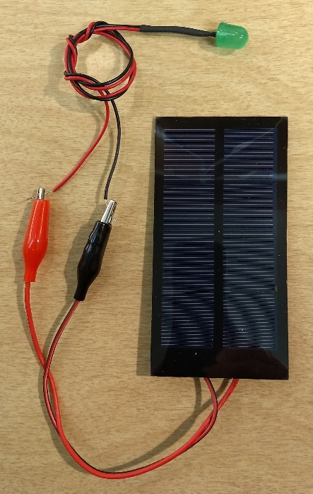

Photo by Doug Weirick

Photo by Doug Weirick