How Solar Cells and Solar Panels Work
Vocabulary List

Boron The chemical element which has atomic number 5 and is represented by a capital letter B. It has a low-abundance in the Earth's crust and trace amounts are naturally found in many foods. Boron is a structural component of plant cell walls and is required for plant growth, pollination, and seed formation. It may also promote bone health in animals.
https://commons.wikimedia.org/wiki/File:Capa_electr%C3%B3nica_005_Boro.svg

Electron A subatomic particle which has a negative electrical charge of one (-1) and a much smaller mass than a proton (approximately 1/1836th of the mass of a proton). Electrons are considered to exist in orbitals around the nuclei of atoms and can be made to flow through electrical conductors. Electrons are also capable of absorbing energy and radiating energy.
https://commons.wikimedia.org/wiki/File:Bohr_model.jpg

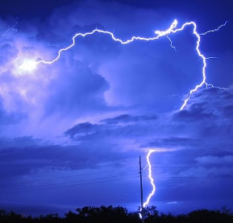
Electricity The movement of electrical charge such as happens when electrons flow through a wire or other electrical conductors. Lightning bolts are a form of electricity with enough energy to cause air to serve as an electrical conductor.
https://commons.wikimedia.org/wiki/File:Lightning_in_Dallas_2015.jpg

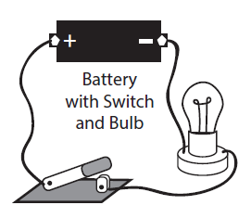
Electrical Circuit A connection of electrical components and conductors such as switches, lights, batteries and wires through which electric charge flows in a closed path.
ElectroWorks Teachers Guide, The National Energy Education Project

Phosphorus The chemical element which has atomic number 15 and is represented by a capital letter P. It is a highly reactive element and is an essential nutrient for all living organisms. Phosphorus is a primary component of nucleic acids (DNA and RNA) and molecules that transfer energy in living organisms such as ATP. It is moderately abundant in the Earth's crust and occurs naturally in soils and rocks.
https://commons.wikimedia.org/wiki/File:Electron_shell_015_Phosphorus_(el).svg

Silicon The chemical element which has atomic number 14 and is represented by the letters Si. It is the second most abundant element in the Earth's crust and it is used to make ceramics, concrete and glass. Silicon is an essential element for some living organisms and some microorganisms and aquatic organisms secrete silica skeletal structures or shells. It is also an essential part of transistors and integrated circuits used in computers and many other electronic devices.
https://commons.wikimedia.org/wiki/File:Electron_shell_014_Silicon_(el).svg

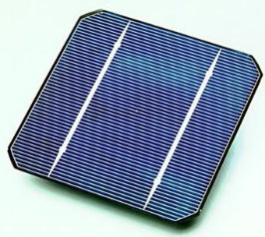
Solar Cell Also called photovoltaic cell, is a small electrical device that converts the energy of light directly into electricity by the photovoltaic effect. Common solar cells are primarily made of silicon with small amounts of other elements such as boron and phosphorus. A single solar cell typically produces direct current electricity with a maximum voltage of approximately 0.5 to 0.6 volts.
https://commons.wikimedia.org/wiki/File:Solar_cell.png

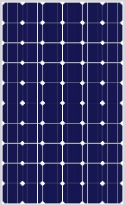
Solar Panel These are also known as photovoltaic modules. Solar panels are commonly composed of multiple solar cells arranged in a single flat plane. The solar cells in solar panels are electrically connected together in such a way that the solar panel can produce higher voltages and electrical currents. https://commons.wikimedia.org/wiki/File:60_Cell_24_Volt_Solar_Panel_Clipart
_foruse_in_wiring_diagrams_and_charts.jpg

